**Cambridge Assessment International Education**

**At both our campuses (Hinjewadi and NIBM), CAGS is a authorised Cambridge International School.**

**We offer the complete Cambridge Pathway (from Cambridge Primary upto AS/A Levels).** The Cambridge Pathway prepares students for life – helping them to develop an informed curiosity and lasting passion for learning.

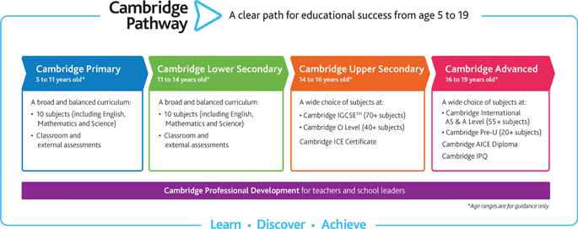

**Cambridge Programmes offered at CAGS**

* **Cambridge Primary (Grades 1 to 5)**
* **Cambridge Secondary 1 Programme (Grades 6 to 8).**
* **Cambridge IGCSE (Grades 9 & 10)**
* **Cambridge AS & A Levels (Grades 11 & 12)**

Students in the Cambridge classroom get to play an active role in the classroom. They will be asked to think critically, to learn how to construct an argument and evaluate evidence. They will learn to work independently, and to collaborate with one another to bring a project to a successful outcome (and if it’s not successful, they’ll also learn lessons from reflecting on why that might be). And they’ll be encouraged to develop an international outlook, and become confident, global citizens.

Academic programmes of Cambridge International help students become confident, responsible, reflective, innovative and engaged. Ready to tackle the demands of tomorrow’s world, capable of shaping a better world for the future.